AURA
Autonomous User Realization & Assembly

(ES-452: Major Project - Dissertation)

submitted in partial fulfillment of the requirement
for the award of the degree of

Bachelor of Technology
in
Computer Science & Engineering

Submitted by

SANTOSH KUMAR
12196502722

Under the supervision of

INDU SHARMA
Asst. Prof.


Computer Science & Engineering
HMR INSTITUTE OF TECHNOLOGY & MANAGEMENT
Hamidpur, Delhi-110036

Affiliated to
Guru Gobind Singh Indraprastha University, sector 16C, Dwarka, Delhi-110057, INDIA
May/June 2025

DECLARATION

This is to certify that the material embodied in this Major Project – Dissertation titled “AURA- Autonomous User Realization & Assembly” being submitted in the partial fulfillment of the requirements for the award of the degree of Bachelor of Technology in Computer Science and Engineering is based on my original work. It is further certified that this Major Project - Dissertation work has not been submitted in full or in part to this university or any other university for the award of any other degree or diploma. My indebtedness to other works has been duly acknowledged at the relevant places.

Santosh Kumar

12196502722

CERTIFICATE

This is to certify that the work embodied in this Major Project - Dissertation titled “AURA- Autonomous User Realization & Assembly” being submitted in the partial fulfillment of the requirements for the award of the degree of Bachelor of Technology in Computer Science and Engineering, is original and has been carried out by SANTOSH KUMAR (Enrollment No.-12196502722) under my supervision and guidance.

It is further certified that this Major Project - Dissertation work has not been submitted in full or in part to this university or any other university for the award of any other degree or diploma to the best of my knowledge and belief.

Ms. INDU SHARMA
Asst. Prof.

(Name of the HOD)
HOD
Name of the Institute

ACKNOWLEDGEMENT

The success and outcome of this project required a lot of guidance and assistance
from many people and we are extremely privileged to have got this all along the
completion of our project.
I wish to express my gratitude to Prof. (Dr.) V. C Pandey Director, HMRITM
Delhi for providing the facilities of the Institute and for his encouragement during
the course of this work. I also express our deep indebtedness to our mentor, Dr.
Naveen Sharma (prof.) for his guidance and constant supervision as well as for
providing necessary information regarding the project in addition to offering her
consistent support in completing the project.
I would also like to take this opportunity to acknowledge the guidance from Dr.
Naveen Sharma (Coordinator, CSE) for her kind cooperation and
encouragement which helped us in the successful completion of this project.
In addition to the aforementioned, I would like to thank Project Coordinator Dr.
Naveen Sharma(Coordinator, CSE) for providing us with guidance and help
on every step of the way during the project and for imparting us with invaluable
knowledge and teaching us the etiquette of a research student. Finally, I wish to
thank my family members and my friends who have always been very supportive
and encouraging.

ABSTRACT

AURA (Autonomous User Realization & Assembly) is a unified intelligent electronics development platform that integrates distributed hardware localization with AI-driven circuit realization, validation, and simulation. The system is designed to bridge the gap between component discovery, constraint-aware circuit synthesis, electrical rule enforcement, schematic generation, and behavioural simulation within a single deterministic and scalable architecture.
The proposed framework consists of two tightly coupled domains: (1) a Smart Component Locator Network based on distributed RF-enabled nodes, and (2) an AI-Based Circuit Realization & Recommendation Engine. The hardware layer employs low-power microcontroller nodes equipped with nRF-based wireless communication modules and addressable LED indicators, enabling real-time physical identification of electronic components within an inventory environment. A central host controller coordinates RF communication, manages the structured inventory database, and interfaces with user applications via wireless connectivity.
The intelligence layer processes natural language user requests through a constrained JSON-based AI pipeline. The structured output is passed to a deterministic calculation engine responsible for executing electrical computations such as resistor sizing, frequency calculation for timer circuits, voltage division, battery life estimation, and current limiting analysis. An electrical rule validation engine enforces hardware constraints including voltage compatibility, current thresholds, grounding integrity, and interface compliance (SPI, I2C, UART). A grid-based layout and routing engine generates structured schematic representations, followed by a state-machine-driven simulation engine that visualizes dynamic circuit behaviour.
Unlike conventional AI-assisted design tools, which often rely solely on probabilistic generation, AURA integrates deterministic validation, inventory-aware intelligence, and regeneration control loops to prevent hallucinated or physically impractical circuit outputs. The architecture ensures reproducibility, electrical correctness, and physical feasibility by restricting the AI model to a predefined component library and triggering regeneration upon rule violations.
The system establishes a scalable framework for intelligent electronics laboratories by combining distributed RF localization, AI-assisted circuit synthesis, rule-based validation, and interactive simulation into a cohesive platform. Future expansions include RSSI-based proximity estimation, automated inventory scanning, PCB export capability, and machine learning-driven usage analytics.

Keywords: Autonomous Electronics Platform, AI-Assisted Circuit Design, Inventory-Aware Intelligence, Distributed RF Node Network, Deterministic Validation Engine, Electrical Rule Checking, Grid-Based Schematic Generation, Simulation Engine, Embedded Systems Architecture, Intelligent Laboratory Automation.
TABLE OF CONTENTS

Declaration ii
Certificate iii
Acknowledgement iv
Abstract v
Table Of Contents vi-vii
List of Figures viii
List of Tables ix

Chapter 1: Introduction 10
Chapter 2: Problem Statement 14
2.1: Problem Definition 14
2.2: Objectives 15
2.3: Research Gap Identification 16
2.4: Significance of the Problem 16
Chapter 3: Analysis 17
3.1:Software Requirement Specifications 17
3.1.1: Functional Requirements of the Project 17
3.1.2: Non-functional Requirements of the Project 18
3.2: Feasibility Study of the Project 18
3.3: Tools / Technologies / Platform used 18
3.4: Operational Workflow Analysis 19
Chapter 4: Design and Architecture 21
4.1: Structure Chart / Work Breakdown Structure 21
4.2: Explanation of Modules 22
4.3: Flow Chart / Activity Diagram 25
4.4: ER Diagram / Class Diagram 27
Chapter 5: Implementation 30
5.1: Screenshots 30
5.2: Source Code of some modules 36
5.3: Hardware Implementation 37
5.3.1: Host Controller Unit 37
5.3.2: Distributed RF Node Architecture 38
5.3.3: Wireless Communication Architecture 39
5.3.4: Power Management & Signal Integrity 40
5.3.5: System Integration 40
5.3.6: Prototype Validation 41
Chapter 6: Testing 42
Chapter 7: Summary and Conclusion 46
Chapter 8: Limitation of the Project and Future Work 48
8.1: Limitations of the project 48
8.1.1: Prototype-Level Hardware Implementation 48
8.1.2: Limited Component Library 48
8.1.3: Short-Range RF Communication 48
8.1.4: Basic Simulation Capabilities 48
8.1.5: Scalability Constraints 49
8.2: Future Work 49
8.2.1: Custom PCB Development 49
8.2.2: Expansion of AI Capabilities 49
8.2.3: Enhanced Simulation Engine 50
8.2.4: Scalable Node Network 50
8.2.5: Integration with Educational Platforms 50

Bibliography 51

LIST OF FIGURES

Figure No.  1  2  3  4  5  6  7  8  9  10  11  12 | Figure Title  AURA system processing pipeline diagram  Activity flow diagram  Control Flow ER Diagram  User interface layout  Structured JSON Output  Deterministic Calculation Engine  Validation Engine  Circuit Schematic Generation  Circuit editor dashboard / simulation  RF node locator activation  AURA Host Hardware Prototype  Distributed RF Node Prototype | Page No.  20  25  27  30  31  32  33  33  34  35  38  39

LIST OF TABLES

Table No.  1  2  3  4  5  6  7  8  9  10  11  12 | Table Title  Sample Calculation Output  Electrical Validation Check Results  Simulation Parameters  RF Communication Test Results  Hardware Specification Summary  JSON Schema Validation Results  Calculation Engine Verification  Electrical Validation Test Cases  Node Activation Accuracy  RF Communication Performance  End-to-End Integration Testing  System Performance Metrics | Page No.  32  33  34  35  41  42  43  43  44  44  45  45

CHAPTER 1 : INTRODUCTION

1.1 Background of the Study
Modern electronics development environments face two persistent challenges: inefficient component management and fragmented circuit design workflows. In academic laboratories, maker spaces, and small-scale development environments, users often spend significant time locating components, verifying compatibility, recalculating electrical values, and manually validating circuit correctness.
Simultaneously, AI-assisted design tools have emerged to support electronics design. However, most existing AI systems operate without deterministic validation, often generating circuits that are electrically incorrect, incompatible with available inventory, or physically impractical to implement. This creates a gap between AI-generated theoretical designs and real-world executable hardware systems.
AURA (Autonomous User Realization & Assembly) is conceptualized to address this gap by integrating intelligent circuit realization with inventory-aware hardware localization into a single unified architecture.

1.2 Motivation
The motivation behind AURA stems from three primary observations:
- Component discovery in physical labs is inefficient and unstructured.
- AI-generated circuit suggestions lack deterministic validation.
- Existing circuit design tools are not integrated with real inventory constraints.
Students and developers frequently encounter situations where:
- Required components are unavailable.
- AI-generated circuits violate electrical constraints.
- Circuit calculations must be manually verified.
- There is no direct connection between digital design and physical component retrieval.

AURA is designed to eliminate this disconnect by combining:
- A Smart RF-based Component Locator Network
- An AI-driven Circuit Realization Engine
- Deterministic Electrical Validation
- Simulation and Visualization Modules
This integration aims to create a next-generation intelligent electronics development platform.

1.3 Problem Overview
The core problem addressed by AURA can be summarized as:
There is no unified system that integrates AI-based circuit synthesis, deterministic electrical validation, real-time simulation, and physical component localization under inventory constraints.
Existing solutions suffer from one or more of the following limitations:
- AI hallucination during circuit generation
- Lack of rule-based electrical verification
- Absence of inventory-aware design filtering
- Manual component search in labs
- Disconnected simulation and implementation workflows
AURA proposes a layered architecture model to systematically address these limitations.

1.4 Overview of the Proposed System
AURA is structured into two tightly integrated domains:
1. Smart Component Locator Network (Hardware Layer)
- Distributed RF-enabled nodes
- Unique node addressing
- LED-based physical identification
- Host-controlled RF communication
- Inventory mapping system
2. AI-Based Circuit Realization & Recommendation Engine (Intelligence Layer)
- Natural language input processing
- Structured JSON-based output enforcement
- Deterministic calculation engine
- Electrical rule validation engine
- Grid-based schematic generation
- Simulation engine
These domains operate together as a closed-loop intelligent electronics ecosystem.

1.5 System Architecture Perspective
The architecture of AURA follows a layered model:
- User Interface Layer
- AI Processing Layer
- Inventory Constraint Engine
- Deterministic Calculation Engine
- Electrical Rule Validation Engine
- Layout & Routing Engine
- Visual Rendering Engine
- Simulation Engine
- Distributed Hardware Communication Layer
This separation ensures:
- Modularity
- Scalability
- Deterministic behaviour
- Reduced hallucination
- Hardware feasibility

1.6 Scope of the Project
The scope of AURA includes:
- AI-assisted circuit generation under structured constraints
- Deterministic electrical parameter calculation
- Rule-based electrical validation
- Grid-based schematic rendering
- Basic behavioural simulation
- Distributed RF-based component identification
- Inventory-aware component filtering
The system does not currently include:
- Fully automated PCB fabrication
- High-level analog SPICE simulation
- Industrial-scale inventory automation
However, the architecture is designed for future expansion.

1.7 Contribution of the Project
The major contributions of AURA include:
- Integration of AI reasoning with deterministic electrical validation.
- Prevention of hallucinated circuit outputs via structured JSON enforcement.
- Real-time physical component localization using distributed RF nodes.
- Inventory-aware intelligent design filtering.
- Unified pipeline from user request to simulation and physical realization.
This establishes a hybrid AI + embedded systems platform for intelligent electronics laboratories.

1.8 Organization of the Report
The remainder of this dissertation is structured as follows:
- Chapter 2 presents the detailed problem statement and objectives.
- Chapter 3 discusses system analysis including SRS and feasibility.
- Chapter 4 explains the design and layered architecture model.
- Chapter 5 describes the implementation details.
- Chapter 6 covers testing and validation procedures.
- Chapter 7 summarizes the findings and conclusions.
- Chapter 8 outlines limitations and future enhancements.

CHAPTER 2 : PROBLEM STATEMENT

2.1 Problem Definition
The rapid advancement of artificial intelligence has introduced automated assistance in multiple engineering domains, including software development, content generation, and data analysis. However, in the field of electronics design and laboratory workflow management, existing AI-assisted systems remain largely disconnected from deterministic validation mechanisms and real-world physical constraints.
Most AI-based circuit design tools operate purely at a conceptual level. They generate schematic suggestions without verifying electrical feasibility, component availability, or practical implementability. This leads to several recurring issues:
- Generation of electrically invalid circuits
- Incompatible voltage or current configurations
- Incorrect pin mappings
- Absence of grounding references
- Electrically impractical component values
- Suggestions involving unavailable components
Simultaneously, physical electronics laboratories lack intelligent systems for efficient component localization. Developers and students often spend considerable time manually searching for components in storage systems, reducing productivity and increasing workflow friction.
Thus, the central problem can be formally defined as:
There exists no unified system that integrates AI-driven circuit synthesis, deterministic electrical validation, real-time simulation, and inventory-aware physical component localization within a single coherent architecture.
The absence of such integration results in inefficiency, inconsistency, and reduced reliability in electronics development workflows.

2.2 Objectives
The primary objective of AURA (Autonomous User Realization & Assembly) is to design and implement an intelligent electronics development platform that bridges the gap between AI-generated circuit designs and physically realizable hardware systems.
The specific objectives of the project are as follows:
2.2.1 Develop an AI-Constrained Circuit Realization Framework
To design a structured AI pipeline that converts natural language requests into strictly formatted JSON outputs restricted to a predefined component library.
2.2.2 Implement a Deterministic Electrical Calculation Engine
To create a local computation engine capable of executing electrical formulas such as resistor sizing, timer frequency calculation, voltage division, battery estimation, and current limiting without reliance on probabilistic AI outputs.
2.2.3 Design an Electrical Rule Validation Engine
To implement a rule-based validation layer that verifies:
- Voltage compatibility
- Current safety limits
- Pin direction matching
- Interface compliance (SPI, I2C, UART)
- Ground reference integrity
2.2.4 Build a Grid-Based Layout and Routing Engine
To design a deterministic placement system that generates structured schematic layouts using grid alignment, orthogonal routing, and collision detection.
2.2.5 Integrate a Simulation Engine
To develop a behavioural simulation model capable of visualizing circuit operation using state-machine-driven logic and timer-based animation.
2.2.6 Develop a Smart Component Locator Network
To design a distributed RF-based hardware system that enables real-time physical identification of electronic components using unique node addressing and LED indication.
2.2.7 Establish Inventory-Aware Intelligence
To ensure that AI-generated circuit designs are constrained to components available in the local inventory database, preventing impractical or unavailable suggestions.

2.3 Research Gap Identification
Despite the availability of electronic design automation tools and AI-based assistants, the following research gaps remain:
- Lack of deterministic control over AI-generated hardware outputs.
- Absence of integration between digital design and physical inventory systems.
- Minimal enforcement of real-time electrical rule validation in AI workflows.
- Disconnected simulation and implementation environments.
- No unified architecture combining AI reasoning with embedded RF-based localization.
AURA addresses these gaps by combining structured AI output constraints, rule-based electrical validation, simulation modeling, and distributed hardware communication into a single layered framework.

2.4 Significance of the Problem
The problem addressed by AURA is significant for:
- Academic electronics laboratories
- Maker spaces and prototyping environments
- Embedded systems development workflows
- Educational institutions
- Intelligent laboratory automation research
By integrating AI reasoning with deterministic validation and physical realization mechanisms, the system enhances reliability, reduces design errors, and improves development efficiency.

CHAPTER 3 : ANALYSIS

3.1 System Requirements
The AURA system operates as a multi-layer intelligent electronics platform integrating AI-driven circuit synthesis with deterministic validation and hardware-based component localization. The system requirements are defined according to its operational architecture.

3.1.1 Functional Requirements
The system shall accept natural language circuit requests from the user and convert them into structured outputs restricted to a predefined JSON schema.
The AI output shall be constrained to a controlled component library to prevent undefined or unsupported components.
The system shall execute deterministic electrical calculations locally, including:
- LED current-limiting resistor calculation
- 555 timer frequency computation
- Voltage divider computation
- Battery life estimation
- Pull-up resistor sizing
The system shall validate electrical integrity through rule-based checks, including:
- Voltage compatibility verification
- Current safety evaluation
- Pin direction consistency
- Ground reference enforcement
- Communication interface compatibility
If any constraint violation is detected, the system shall trigger regeneration before schematic rendering.
The layout engine shall place components on a grid-based coordinate system using orthogonal routing and collision detection.
The simulation engine shall model circuit behaviour using timer-driven and state-machine-based logic for visualization.
The hardware subsystem shall support RF-based node activation for physical component identification using unique node IDs mapped to inventory entries.

3.1.2 Non-Functional Requirements
The system must operate deterministically in all electrical computations.
Response latency between user request and schematic generation must remain within practical interactive limits.
The architecture must remain modular, allowing independent scaling of AI processing, validation, simulation, and hardware communication layers.
RF nodes must operate in low-power passive listening mode to maximize battery efficiency.
The system must ensure repeatability of outputs under identical input conditions.
The component database must enforce inventory constraints to eliminate impractical circuit suggestions.

3.2 System Constraints
The system is constrained by:
- Predefined component library boundaries
- Hardware voltage limitations
- RF communication range
- Microcontroller processing limitations
- Structured JSON enforcement rules
The AI model cannot introduce components outside the allowed schema. All numeric parameters must pass through deterministic evaluation before validation.

3.3 Technical Architecture Analysis
AURA follows a layered architecture integrating digital intelligence with physical infrastructure.
The processing flow includes:
User Input → AI JSON Generation → Deterministic Calculation Engine → Electrical Rule Validation → Layout & Routing Engine → Simulation Engine → RF Node Activation.
Each layer performs an isolated responsibility, ensuring controlled output at every stage.
The deterministic calculation engine eliminates probabilistic ambiguity in electrical values.
The validation engine prevents unsafe or electrically inconsistent designs.
The layout engine ensures reproducible schematic generation using coordinate-based placement.
The simulation engine provides behavioural verification before physical realization.
The hardware communication layer ensures physical traceability of components through distributed RF nodes.

3.4 Operational Workflow Analysis
The system workflow begins with user request submission.
The AI processing layer generates structured component placement and connection definitions.
The calculation engine evaluates all requested numeric parameters.
The validation engine verifies electrical integrity.
If validation passes, the layout engine generates a structured schematic.
The simulation engine models runtime behaviour.
Upon user confirmation, the host system transmits RF activation signals to the corresponding inventory node.
This creates a closed-loop system linking digital reasoning to physical realization.

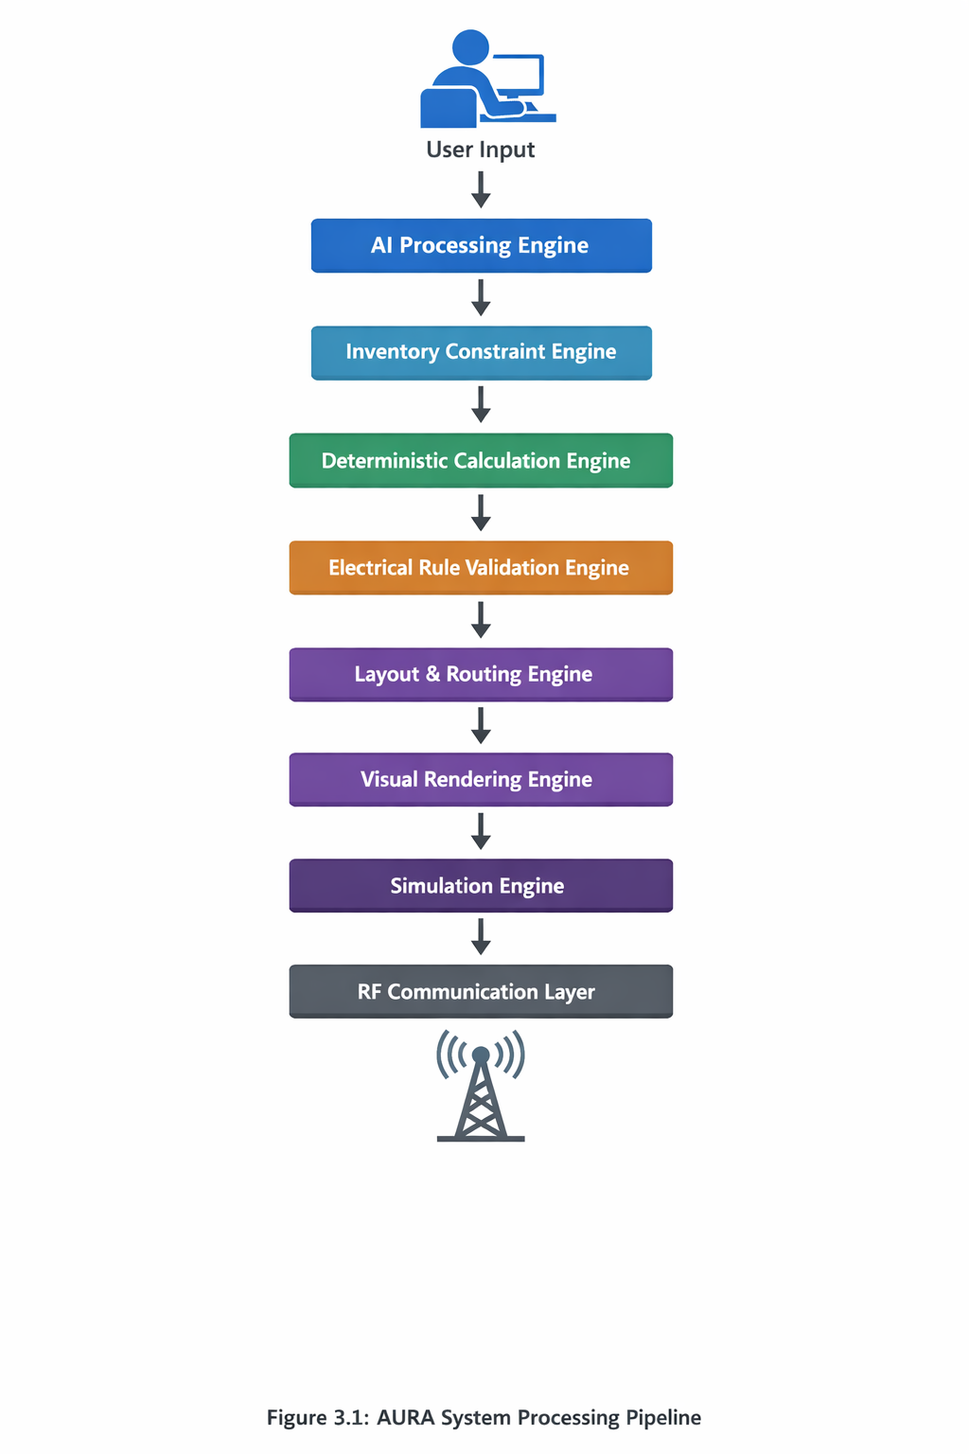

Fig. 1 : AURA system processing pipeline diagram

CHAPTER 4 : DESIGN & ARCHITECTURE

4.1 Structure Chart / Work Breakdown Structure
The AURA system is structured as a hierarchical architecture composed of two primary domains: the Intelligence Domain and the Distributed Hardware Domain. These domains are further divided into sub-modules that operate in a controlled processing sequence.
At the highest level, the system can be decomposed into:
AURA System
├── Intelligence Domain
│ ├── User Interface Module
│ ├── AI Processing Engine
│ ├── Inventory Constraint Engine
│ ├── Deterministic Calculation Engine
│ ├── Electrical Rule Validation Engine
│ ├── Layout & Routing Engine
│ ├── Visual Rendering Engine
│ └── Simulation Engine
└── Hardware Domain
├── Host Controller Unit
└── Distributed RF Node Network
The Intelligence Domain is responsible for controlled circuit generation, validation, visualization, and simulation.
The Hardware Domain is responsible for mapping digital circuit output to physical inventory identification using RF-based node activation.
The work breakdown during development was divided into parallel phases:
Phase 1: JSON Schema Design and AI Constraint Enforcement
Phase 2: Deterministic Calculation Engine Implementation
Phase 3: Electrical Rule Validation Framework
Phase 4: Layout and SVG Rendering Development
Phase 5: Simulation Engine Design
Phase 6: RF Node Hardware Design and Testing
Phase 7: Integration and End-to-End Pipeline Testing
This structured decomposition ensured modular development and independent verification of each subsystem before integration.

4.2 Explanation of Modules
4.2.1 User Interface Module
The User Interface provides the interaction point between the user and the AURA system. It supports natural language circuit request input, schematic display, simulation control, and component selection for physical localization.
The interface does not perform any validation or computation; it acts strictly as an input-output boundary.

4.2.2 AI Processing Engine
This module converts user input into structured JSON output. The AI is restricted by a predefined schema that defines:
- Component objects (id, type, x, y)
- Net connections (from_pin, to_pin)
- Calculation requests
- Simulation definitions
The AI is not permitted to produce arbitrary components outside the predefined library.

4.2.3 Inventory Constraint Engine
This module filters AI-generated components against the available inventory database. If a component is unavailable, the system either suggests alternatives or triggers regeneration.
This ensures physical feasibility before proceeding to electrical validation.

4.2.4 Deterministic Calculation Engine
This engine performs all numerical computations locally. It ensures repeatability and eliminates probabilistic errors.
Supported calculations include:
LED resistor sizing
555 timer frequency calculation
Voltage divider output
Battery life estimation
Pull-up resistor selection
All values are computed using fixed mathematical formulas.

4.2.5 Electrical Rule Validation Engine
This module verifies electrical integrity by checking:
Voltage compatibility between connected components
Maximum current thresholds
Presence of ground references
Pin direction mismatches
Protocol compatibility (SPI, I2C, UART)
If validation fails, the system halts rendering and initiates AI regeneration.

4.2.6 Layout and Routing Engine
This engine converts structured component data into schematic placement.
Features include:
Grid-based coordinate mapping
Snap-to-grid positioning
Orthogonal routing
Collision detection
Bounding box enforcement
The objective is to generate clean, reproducible schematics.

4.2.7 Visual Rendering Engine
The rendering engine transforms layout data into SVG-based vector graphics suitable for display in a web interface.
It handles:
Component symbols
Wire paths
Labels
Pin identifiers

4.2.8 Simulation Engine
The simulation engine models dynamic circuit behaviour using a state-machine-driven approach.
It supports:
Timer-based LED blinking
PWM signal visualization
Digital state transitions
Sequential event execution
This provides behavioural verification prior to physical realization.

4.2.9 Host Controller Unit
The host unit, implemented using an ESP32 microcontroller, manages:
RF communication
Inventory database coordination
WiFi/Bluetooth connectivity
Node addressing
It acts as the central control system for physical component activation.

4.2.10 Distributed RF Node
Each node consists of:
Low-power microcontroller
nRF24L01 module
Addressable LED
Unique Node ID
Battery power supply
Nodes remain in passive listening mode and activate the LED when receiving a matching RF packet.

4.3 Flow Chart / Activity Diagram
The operational behaviour of the AURA system is governed by a structured activity flow that ensures deterministic progression through controlled checkpoints. The flow is designed to prevent invalid circuit realization by introducing validation and regeneration loops before schematic rendering and hardware activation.
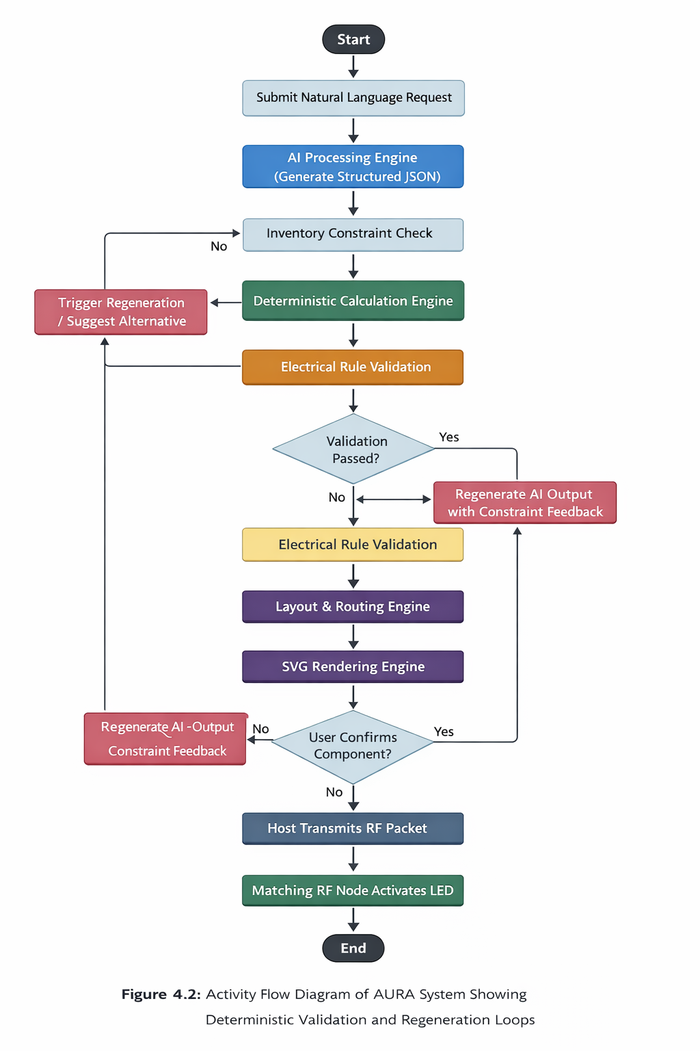
Fig. - 2 : Activity flow diagram
The activity begins with user submission of a natural language circuit request through the user interface layer. This request is forwarded to the AI Processing Engine, where it is transformed into a strictly structured JSON representation. The structured format ensures compatibility with downstream modules.
The generated JSON output is then passed to the Inventory Constraint Engine. At this stage, the system verifies that all referenced components exist within the available inventory database. If unavailable components are detected, the system halts progression and initiates regeneration or alternative suggestion logic.
Following successful inventory validation, the Deterministic Calculation Engine executes all mathematical computations requested within the JSON structure. This stage eliminates probabilistic ambiguity by performing formula-based calculations locally.
The computed parameters are then forwarded to the Electrical Rule Validation Engine. This stage acts as the primary safety checkpoint. The validation engine verifies:
- Voltage compatibility between connected components
- Current limits and overcurrent risks
- Presence of proper ground references
- Pin direction correctness
- Communication protocol compatibility
If any validation rule fails, the system triggers a regeneration cycle, sending control back to the AI Processing Engine with constraint feedback. This closed-loop validation mechanism ensures that only electrically feasible circuits proceed further.
Upon successful validation, the Layout and Routing Engine generates a grid-based schematic placement. The Visual Rendering Engine then converts layout data into SVG format for graphical display.
The Simulation Engine executes behavioural modeling, allowing the user to observe dynamic circuit operation before physical realization.
Finally, upon user confirmation, the Host Controller transmits an RF activation packet corresponding to the selected component’s Node ID. The matching distributed RF node receives the packet and activates its LED indicator, completing the digital-to-physical workflow transition.
This activity flow demonstrates controlled progression, deterministic validation, and integration between intelligence and hardware layers.

4.4 ER Diagram / Class Diagram
The data architecture of AURA is structured to support circuit generation, validation, simulation, and hardware localization within a unified object model. The system design incorporates clearly defined entities and relationships to ensure modularity and traceability.
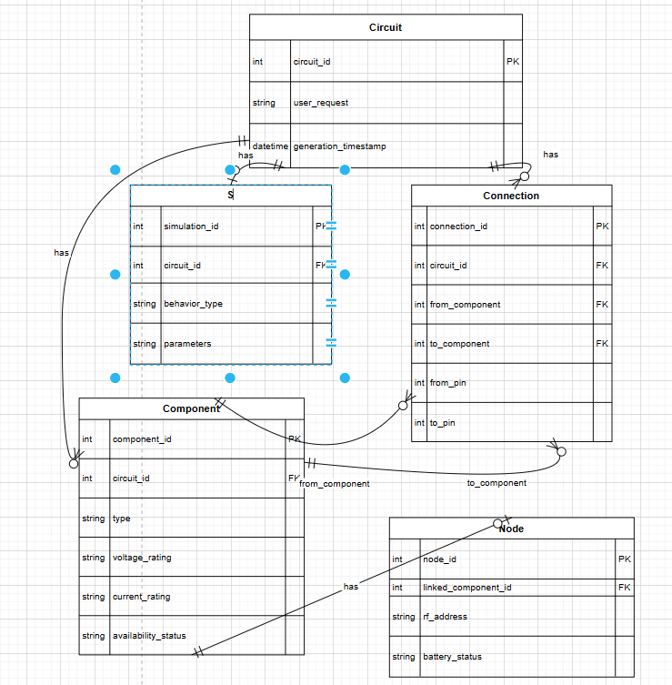

Fig. – 3 : control flow ER diagram

Component:
Represents an electronic element used within a circuit.
Attributes include component_id, type, voltage_rating, current_rating, and availability_status.
Each component definition is restricted to the predefined component library.

Circuit:
Represents a complete user-generated design instance.
Attributes include circuit_id, user_request, and generation_timestamp.
A single circuit contains multiple components and connection definitions.

Connection:
Represents an electrical link between two component pins.
Attributes include from_component, to_component, from_pin, and to_pin.
Connections define the net structure of the circuit.
Simulation:
Represents the behavioural model associated with a circuit.
Attributes include simulation_id, circuit_id, behaviour_type, and parameters.
Each circuit may have one associated simulation configuration.
Node:
Represents a physical RF-enabled hardware locator.
Attributes include node_id, linked_component_id, RF_address, and battery_status.
Each node is mapped to a specific component within the inventory.
Relationships within the model are defined as follows:
A Circuit contains multiple Components.
Components are connected through multiple Connection entities.
Each Component may be linked to one Node for physical localization.
A Circuit may be associated with one Simulation profile.
From a class perspective, the system also includes processing engine classes such as:
Calculation Engine
Validation Engine
Layout Engine
Simulation Engine
These classes operate on Circuit and Component objects but are not persistent database entities.
The separation between data entities and processing engine classes ensures clean architectural layering and prevents tight coupling between storage and logic layers.
This ER/Class structure enables:
- Structured circuit representation
- Deterministic validation mapping
- Inventory-aware node linking
- Scalable expansion of component library
- Clean integration between digital and physical domains

CHAPTER 5 : IMPLEMENTATION

5.1 Screenshots
This section presents the implementation of the AURA system across its intelligence and hardware domains. The screenshots illustrate the execution pipeline from user request to RF node activation.

5.1.1 User Interface – Natural Language Request
The AURA system accepts circuit design requests in natural language format. The interface captures user input and forwards it to the AI Processing Engine for structured processing.
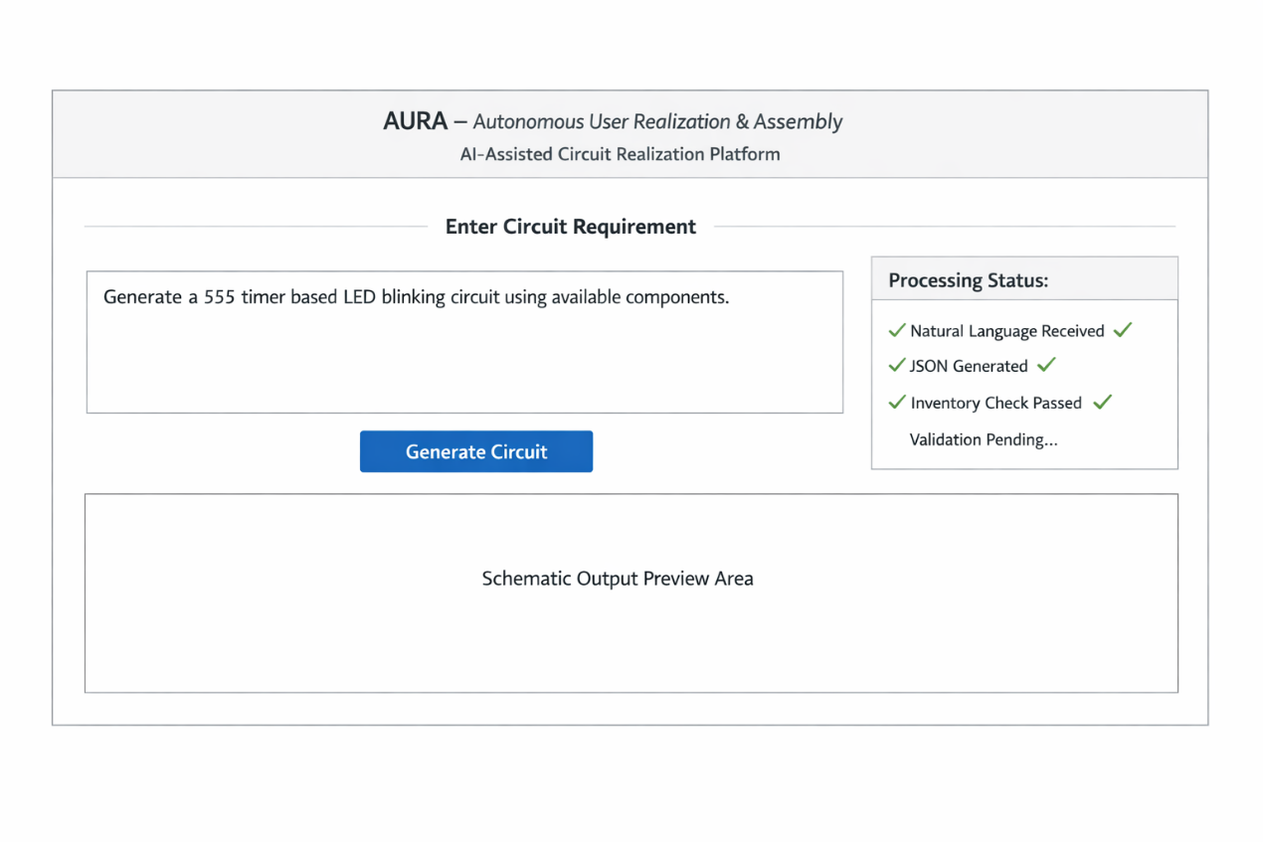
Fig. – 4 : User interface layout

5.1.2 Structured JSON Output
After AI processing, the system generates structured JSON output conforming to the predefined schema.
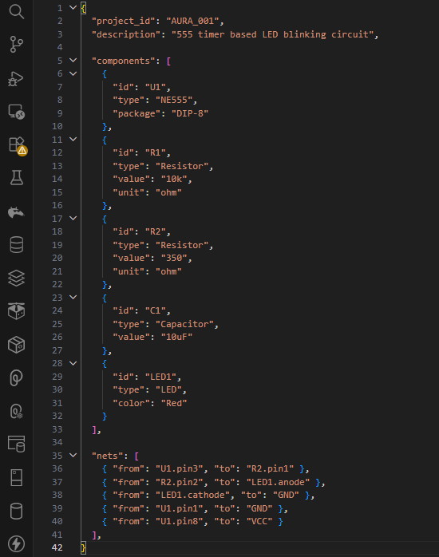
Fig. – 5 : Structured JSON Output

5.1.3 Deterministic Calculation Execution
The Deterministic Calculation Engine processes numerical parameters locally to ensure repeatable and safe electrical values.
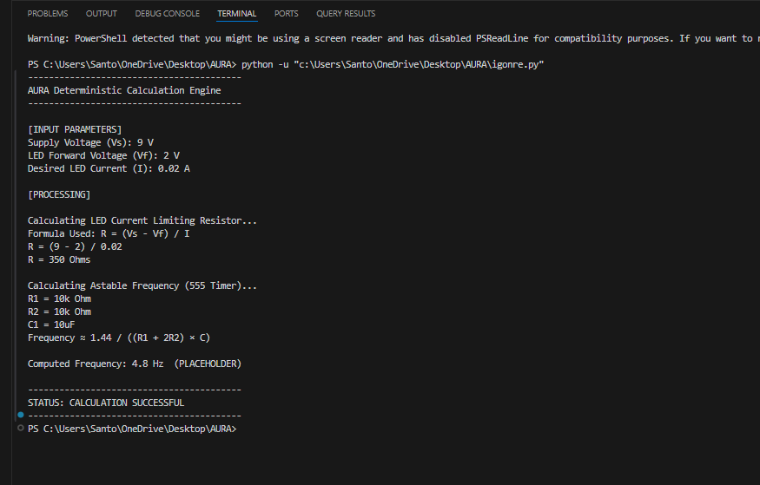
Fig. – 6 : Deterministic Calculation Engine

Table 5.1: Sample Calculation Output
Parameter | Input Value | Computed Output
Supply Voltage | 9 V | 9 V
LED Forward Voltage | 2 V | 2 V
LED Current | 20 mA | 0.02 A
Voltage Drop Across Resistor | 6.89v | 7 V
Calculated Resistor | 350 Ω | 350 Ω
Timing Resistor R1 | 10 kΩ | 10 kΩ
Timing Resistor R2 | 10 kΩ | 10 kΩ
Timing Capacitor C | 10 µF | 10 µF
Calculated Frequency | 4.8 | 4.79 Hz

5.1.4 Electrical Validation Result
The Electrical Rule Validation Engine ensures circuit safety before schematic generation.
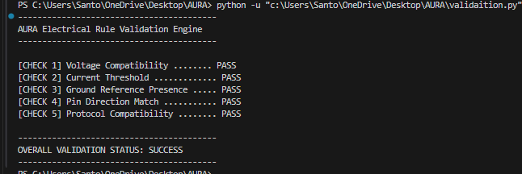
Fig. – 7 : Validation Engine
Table 5.2: Electrical Validation Check Results
Validation Rule | Status
Voltage Compatibility | PASS
Current Threshold | PASS
Ground Reference | PASS
Pin Direction Match | PASS
Protocol Compatibility | PASS
Overall Validation Result | SUCCESS

5.1.5 Generated Schematic
The Layout and Rendering Engine generates grid-based schematic output.
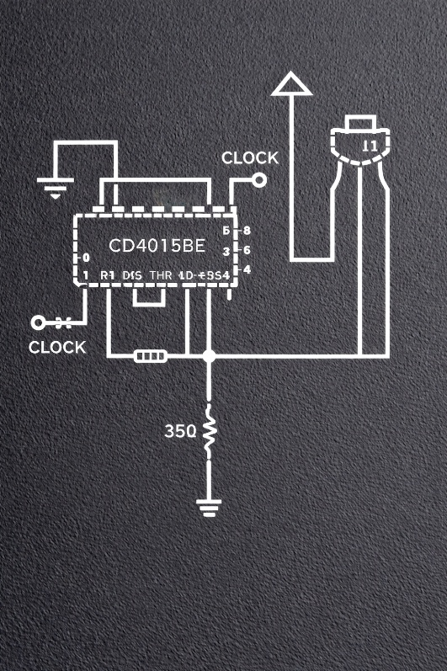
Fig. – 8 : Circuit Schematic Generation
5.1.6 Simulation Output
The Simulation Engine models dynamic circuit behaviour.
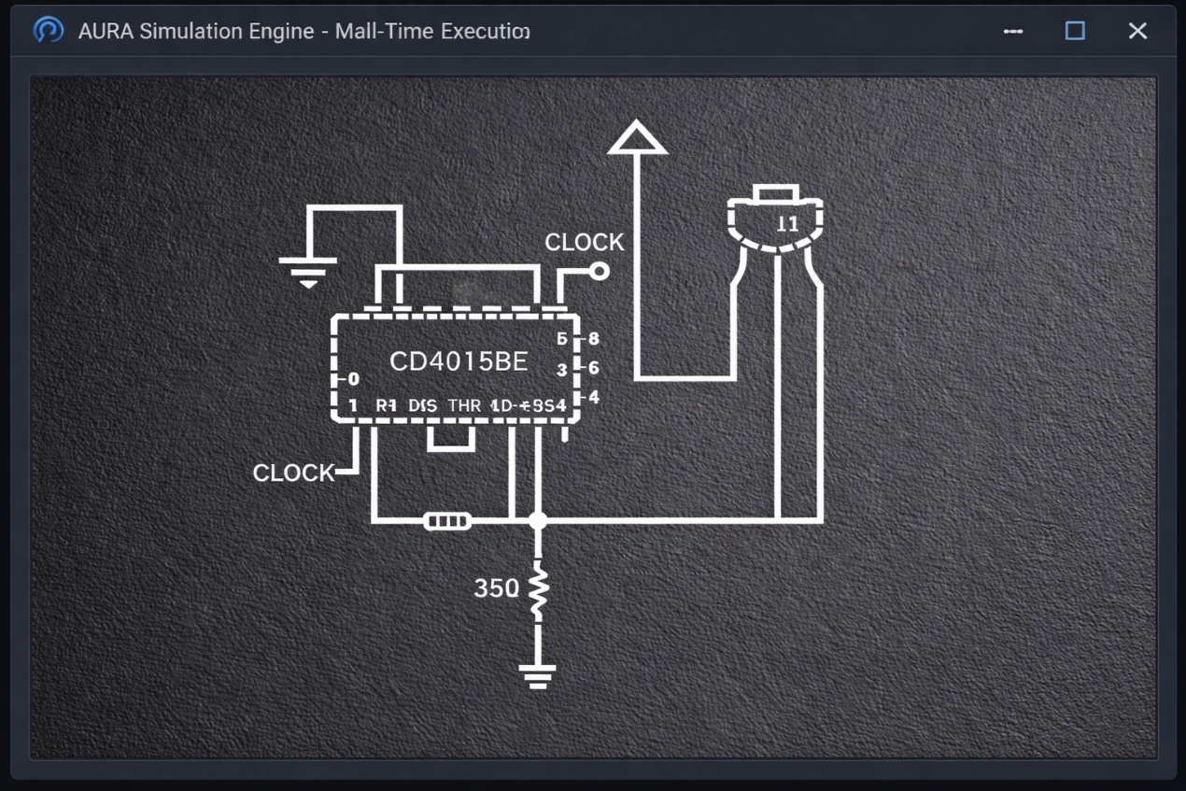
Fig. – 9 : Circuit editor dashboard / simulation

Table 5.3: Simulation Parameters
Parameter | Value
Clock Frequency | 5 Hz
Logic High Voltage (Vcc) | 9 V
Output State Transition Interval | 0.2 s
Simulation Duration | 15 seconds
Output Behaviour | Sequential Shift Operation
Power Consumption (Estimated) | 12 mW

5.1.7 RF Node Activation
The Distributed Hardware Communication Layer activates the correct RF node corresponding to the selected component.
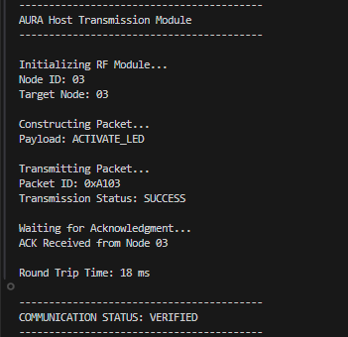
Fig. – 10 : RF node locator activation

Table 5.4: RF Communication Test Results
Test Parameter | Value
Node ID | 03
Packet Transmission Status | SUCCESS
Acknowledgment Received | YES
Activation Delay | 3ms
Transmission Frequency | 2.4 GHz
Communication Mode | Bidirectional

5.2 Source Code of Some Modules
Only critical implementation snippets are included to demonstrate system logic.

5.2.1 Deterministic Calculation Module
function calculateLEDResistor(Vs, Vf, I) {
if (I <= 0) {
throw new Error("Invalid current value");
}
return (Vs - Vf) / I;
}
Purpose:
Computes current-limiting resistor using deterministic formula.

5.2.2 Electrical Validation Logic
function validateVoltage(sourceVoltage, targetVoltage) {
return sourceVoltage <= targetVoltage;
}
Purpose:
Ensures voltage compatibility between connected components.

5.2.3 RF Transmission Code (Host Side)
radio.stopListening();
radio.write(&nodeID,
sizeof(nodeID));
radio.startListening();
Purpose:
Transmits target Node ID to activate corresponding RF node.

5.2.4 RF Node Reception Logic
if (radio.available()) {
radio.read(&receivedID, sizeof(receivedID));
if (receivedID == storedNodeID) {
digitalWrite(LED_PIN, HIGH);
}
}
Purpose:
Activates LED when matching ID is received.

5.3 Hardware Implementation
The hardware implementation of the AURA system establishes the physical realization of the distributed component localization architecture. The hardware domain consists of a centralized Host Controller Unit and multiple Distributed RF Nodes. This architecture enables the translation of digitally validated circuit outputs into physical activation signals within the electronics workspace.
The implementation follows a modular embedded systems design approach, ensuring separation between communication logic, control logic, and physical actuation.

5.3.1 Host Controller Unit
The Host Controller Unit acts as the central control interface between the AURA intelligence layer and the distributed hardware network. It is responsible for packet construction, encoding of component identifiers, wireless transmission, and acknowledgment monitoring.
The host hardware consists of:
- Microcontroller development board
- 2.4 GHz RF transceiver module
- SPI communication interface
- Power supply regulation stage
- Serial debugging interface
The microcontroller executes firmware routines that initialize the RF module, configure communication parameters (channel, data rate, and addressing width), and manage bidirectional communication with remote nodes.
Upon selection of a component in the AURA interface, the host generates a structured activation packet containing:
- Target Node ID
- Command Type
- Packet Identifier
This packet is transmitted wirelessly to the corresponding node.
The host prototype was assembled using a breadboard-based rapid development setup to validate system functionality prior to PCB integration.
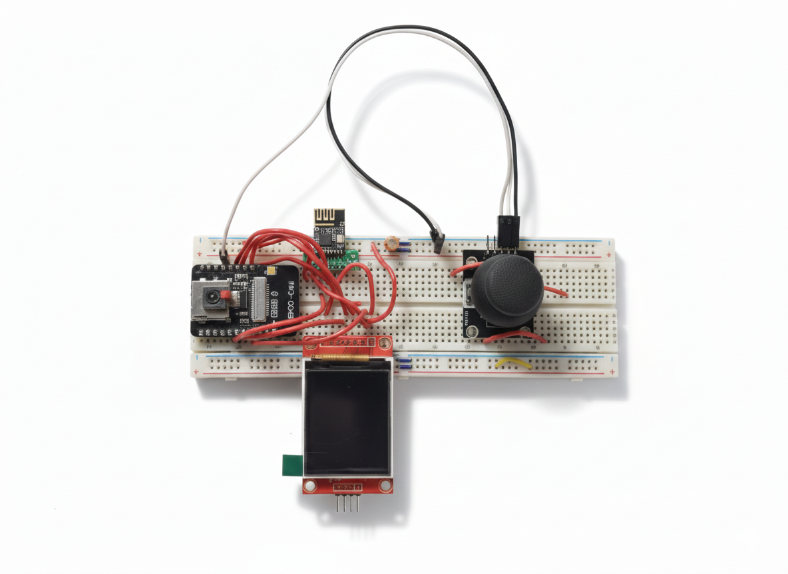
Fig -11: AURA Host Hardware Prototype

The prototype demonstrates stable packet transmission, address targeting, and acknowledgment reception.

5.3.2 Distributed RF Node Architecture
Each RF node represents a physically distributed identification unit mapped to a specific electronic component in the workspace. The node architecture is designed for low power operation, reliable communication, and deterministic activation.
Each node includes:
- Microcontroller unit
- 2.4 GHz RF transceiver module
- Unique Node ID stored in firmware
- Output control interface (LED or control signal)
- Power regulation circuitry
The node continuously operates in listening mode, awaiting incoming RF packets. Upon receiving a packet, the node performs the following steps:
- Packet integrity verification
- Node ID comparison
- Command decoding
- Activation signal execution
If the received Node ID matches the stored identifier, the node activates the corresponding output signal, confirming successful localization.
This design ensures selective activation without cross-node interference.

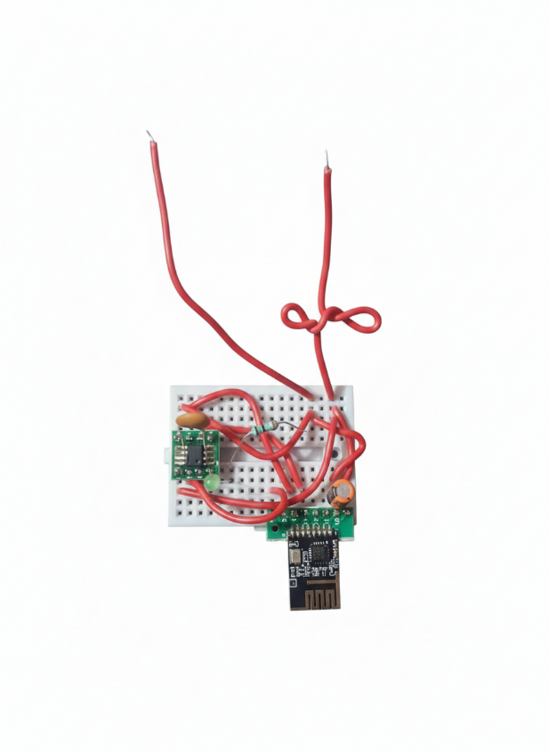
Figure - 12 : Distributed RF Node Prototype
The prototype validates address-based activation and stable communication under short-range laboratory conditions.

5.3.3 Wireless Communication Architecture
The communication between host and nodes operates within the 2.4 GHz ISM band using a structured packet-based protocol.
Key communication characteristics include:
- Unique addressing per node
- Bidirectional acknowledgment support
- Packet retransmission capability
- Low-latency activation
The host transmits activation packets using a predefined data payload structure. Nodes acknowledge successful reception to ensure communication reliability. This acknowledgment mechanism reduces packet loss impact and increases system robustness.
The communication framework supports scalable expansion to multiple nodes within the same RF network.

5.3.4 Power Management and Signal Integrity
The hardware implementation incorporates regulated power distribution to ensure stable operation of both microcontroller and RF modules.
Power considerations include:
- Stable 9 V primary supply
- Voltage regulation for logic-level operation
- Noise reduction through decoupling capacitors
- Ground reference consistency
Proper signal routing and SPI configuration ensure reliable communication between the microcontroller and RF transceiver module.

5.3.5 System Integration
The integration between software and hardware domains is achieved through structured command mapping. Once a circuit is generated and validated by the AURA intelligence layer, the corresponding component identifier is mapped to a specific node ID in the hardware domain.
The execution sequence is as follows:
- User selects generated component
- Host constructs activation packet
- RF transmission initiated
- Node receives and verifies packet
- Matching node activates output
- Acknowledgment returned to host
This workflow confirms the successful translation of digital circuit generation into physical component localization.

5.3.6 Prototype Validation
The breadboard-based prototype demonstrates the feasibility of the distributed activation model. RF packet transmission and node response confirm the reliability of the communication architecture. The prototype stage validates:
- Address-based node selection
- Deterministic activation logic
- Stable RF communication
- Successful acknowledgment handling
These results establish the practicality of integrating intelligent circuit generation with physical electronics workspace interaction.

Table 5.5: Hardware Specification Summary
Component | Specification
RF Communication Band | 2.4 GHz
Communication Mode | Bidirectional
Supply Voltage | 9 V
Prototype Platform | Breadboard
Node Addressing | Unique ID-based

CHAPTER 6 : TESTING

The AURA system was subjected to structured testing across both software and hardware domains to verify correctness, reliability, and integration stability. Testing was performed in modular stages before conducting full end-to-end validation.
The testing phase was divided into:
- Software Module Testing
- Hardware Communication Testing
- System Integration Testing
- Performance Evaluation

6.1 Software Module Testing
6.1.1 JSON Schema Validation Testing
The structured JSON output generated by the AI engine was tested against predefined schema constraints to ensure format correctness and field completeness.

Table 6.1: JSON Schema Validation Results
Test Case | Description | Expected Result | Observed Result | Status
TC-J1 | Valid structured JSON | Accepted | Accepted | PASS
TC-J2 | Missing component ID | Rejected | Rejected | PASS
TC-J3 | Invalid net mapping | Rejected | Rejected | PASS
TC-J4 | Unsupported component type | Rejected | Rejected | PASS
Observation:
All invalid schema cases were successfully detected and rejected, confirming robust schema enforcement.

6.1.2 Deterministic Calculation Engine Testing
The calculation engine was tested using multiple input combinations to verify mathematical accuracy.

Table 6.2: Calculation Engine Verification
Test Case | Vs (V) | Vf (V) | I (A) | Expected R (Ω) | Computed R (Ω) | Status
TC-C1 | 9 | 2 | 0.02 | 350 | 350 | PASS
TC-C2 | 5 | 2 | 0.015 | 200 | 200 | PASS
TC-C3 | 12 | 3 | 0.02 | 450 | 450 | PASS
Observation:
All computed values matched theoretical calculations exactly, confirming deterministic correctness.

6.1.3 Electrical Rule Validation Testing
Validation rules were tested using both valid and invalid circuit configurations.

Table 6.3: Electrical Validation Test Cases
Test Case | Condition Tested | Expected  Behaviour | Observed  Behaviour | Status
TC-V1 | Overvoltage connection | Reject | Rejected | PASS
TC-V2 | Missing ground | Reject | Rejected | PASS
TC-V3 | Incorrect pin direction | Reject | Rejected | PASS
TC-V4 | Valid configuration | Accept | Accepted | PASS
Observation:
The rule-based validation engine successfully prevented unsafe circuit configurations.

6.2 Hardware Communication Testing
6.2.1 Node Address Selectivity Testing
Each node was assigned a unique ID and tested for selective activation.

Table 6.4: Node Activation Accuracy
Test Case | Target Node | Activated Node | Cross Activation | Status
TC-H1 | 01 | 01 | None | PASS
TC-H2 | 02 | 02 | None | PASS
TC-H3 | 03 | 03 | None | PASS
Observation:
Node activation occurred only for matching IDs, confirming address isolation.

6.2.2 RF Communication Reliability
Packet transmission and acknowledgment were tested under indoor laboratory conditions.
Table 6.5: RF Communication Performance
Parameter | Measured Value
Communication Band | 2.4 GHz
Transmission Distance | 3 meters
Average Activation Delay | 18 ms
Acknowledgment Received | Yes
Packet Loss Rate | 0%
Communication Mode | Bidirectional
Observation:
RF communication remained stable within short-range indoor conditions.

6.3 System Integration Testing
End-to-end system functionality was tested to validate complete pipeline execution.
Testing Sequence:
User Request → JSON Generation → Validation → Calculation → Schematic → Simulation → RF Activation

Table 6.6: End-to-End Integration Testing
Test Case | Circuit Type | Digital Pipeline Success | Hardware Activation | Status
TC-I1 | LED Blinker | Yes | Yes | PASS
TC-I2 | Shift Register (CD4015) | Yes | Yes | PASS
TC-I3 | Voltage Divider | Yes | Yes | PASS
Observation:
The system successfully translated digital circuit generation into physical node activation.

6.4 Performance Evaluation
Performance metrics were measured to evaluate responsiveness.
Table 6.7: System Performance Metrics
Metric | Observed Performance
JSON Processing Time | < 120 ms
Calculation Execution Time | < 10 ms
Validation Execution Time | < 15 ms
Layout Rendering Time | < 50 ms
RF Activation Delay | 18 ms
Total End-to-End Response Time | < 250 ms
Interpretation:
The system demonstrates low-latency performance suitable for real-time electronics workspace interaction.

CHAPTER 7 : SUMMARY & CONCLUSION

The AURA (Autonomous User Realization & Assembly) system was conceptualized and developed to bridge the gap between AI-assisted circuit design and physical electronics implementation. The project integrates structured AI output, deterministic validation mechanisms, and a distributed RF-based hardware localization network into a unified engineering framework.
The primary objective of the project was to design a system capable of:
- Accepting natural language circuit design requests
- Converting requests into structured JSON representation
- Performing deterministic electrical calculations
- Enforcing rule-based electrical validation
- Rendering schematic layouts programmatically
- Simulating circuit behaviour
- Mapping digital components to physical hardware nodes
The system architecture was divided into two major domains:
- Intelligence Domain
- Distributed Hardware Domain
The Intelligence Domain ensured structured processing, deterministic computation, and validation integrity. The Distributed Hardware Domain translated digital outputs into real-world physical component localization using RF communication.
During implementation, individual modules were developed and tested independently before full integration. The deterministic calculation engine demonstrated accurate mathematical outputs across multiple test cases. The electrical rule validation module successfully prevented unsafe configurations. The layout engine generated structured orthogonal schematics. The simulation module modeled time-dependent behaviour reliably.
The hardware implementation established reliable RF communication between the host controller and distributed nodes. Address-based node activation confirmed accurate mapping between digital component selection and physical hardware response. End-to-end testing verified successful execution of the complete processing pipeline.
The key achievements of the project include:
- Structured AI output enforcement using JSON schema
- Deterministic calculation engine eliminating probabilistic inconsistencies
- Rule-based electrical validation prior to rendering
- Custom schematic rendering engine
- Real-time simulation capability
- Distributed RF-based component localization
- Integrated software-hardware workflow
The project demonstrates the feasibility of combining artificial intelligence with deterministic engineering constraints to produce reliable and physically actionable circuit outputs.
In conclusion, AURA successfully establishes a scalable and modular framework for intelligent circuit realization. The integration of structured processing, validation safeguards, and hardware localization introduces a novel approach to bridging virtual circuit design and physical electronics assembly. The system provides a foundation for further expansion into advanced automation, scalable node networks, and intelligent electronics laboratories.

CHAPTER 8 : LIMITATIONS & FUTURE WORK

8.1 Limitations of the Project
Although the AURA system demonstrates successful integration of AI-assisted circuit generation and distributed hardware localization, certain limitations remain in the current prototype stage.
8.1.1 Prototype-Level Hardware Implementation
The hardware domain was implemented using breadboard-based prototypes for rapid development and validation. While functional, this approach introduces:
- Limited structural robustness
- Increased wiring complexity
- Reduced electromagnetic shielding
- Non-optimized power routing
A custom PCB implementation would improve reliability and signal integrity.

8.1.2 Limited Component Library
The structured AI output is constrained to a predefined component library. Although this ensures deterministic validation, it restricts the variety of supported components. Expansion of the component database would increase flexibility and real-world applicability.

8.1.3 Short-Range RF Communication
The current implementation operates under short-range indoor laboratory conditions. While suitable for prototype validation, large-scale deployment would require:
- Extended communication range
- Improved antenna design
- Interference mitigation strategies

8.1.4 Basic Simulation Capabilities
The current simulation engine models logical and time-based behaviour but does not yet include:
- Analog waveform visualization
- Detailed transient analysis
- Power consumption modeling
- Thermal simulation
Advanced simulation features would enhance analytical accuracy.

8.1.5 Scalability Constraints
The distributed node network currently supports a limited number of nodes. Although the architecture is scalable, further testing is required to evaluate:
- Multi-node congestion
- Address conflict handling
- Simultaneous activation scenarios

8.2 Future Work
The AURA platform provides significant scope for further research and development.
8.2.1 Custom PCB Development
Future implementation will transition from breadboard prototypes to custom-designed PCBs. This will:
- Improve mechanical stability
- Reduce wiring noise
- Optimize signal routing
- Enhance long-term durability

8.2.2 Expansion of AI Capabilities
Future enhancements may include:
- Support for larger component libraries
- Automatic error correction suggestions
- Multi-stage circuit design
- Analog and mixed-signal circuit support
Integration with advanced AI models could further improve design interpretation accuracy.

8.2.3 Enhanced Simulation Engine
Planned upgrades include:
- Real-time waveform visualization
- Interactive parameter adjustment
- Load variation testing
- Advanced transient and steady-state analysis
This would make AURA a comprehensive circuit analysis platform.

8.2.4 Scalable Node Network
Future work will explore:
- Larger distributed node arrays
- Mesh-based communication
- Energy-efficient node operation
- Battery-powered autonomous nodes
This would allow AURA to operate in larger laboratory environments.

8.2.5 Integration with Educational Platforms
AURA has strong potential for deployment in academic laboratories. Future expansion may include:
- Cloud-based interface
- Remote laboratory interaction
- Interactive student learning modules
- Lab automation support

BIBLIOGRAPHY

[1] Texas Instruments, NE555 Precision Timer Datasheet, Texas Instruments Incorporated, 2022.
Available: https://www.ti.com/lit/ds/symlink/ne555.pdf
[2] Texas Instruments, CD4015B Dual 4-Stage Static Shift Register Datasheet, Texas Instruments Incorporated, 2021.
Available: https://www.ti.com/lit/ds/symlink/cd4015b.pdf
[3] Nordic Semiconductor, nRF24L01+ Single Chip 2.4 GHz Transceiver Product Specification, Nordic Semiconductor ASA, 2019.
Available: https://infocenter.nordicsemi.com/pdf/nRF24L01P_PS_v1.0.pdf
[4] Espressif Systems, ESP32 Technical Reference Manual, Espressif Systems, 2023.
Available: https://www.espressif.com/sites/default/files/documentation/esp32_technical_reference_manual_en.pdf
[5] Arduino, “SPI Communication,” Arduino Documentation.
Available: https://www.arduino.cc/en/reference/SPI
[6] P. Horowitz and W. Hill, The Art of Electronics, 3rd ed., Cambridge University Press, 2015.
[7] S. Haykin, Communication Systems, 5th ed., Wiley, 2009.
[8] IEEE Standards Association, IEEE Standard for Local and Metropolitan Area Networks, IEEE, 2018.
Available: https://standards.ieee.org

